Selectable Drive Mode Control Function - S550 Specific - CGEA 1.3

Functional Description

The Selectable Drive Mode (SDM) Control Function allows a driver to cycle through a number of preset drive modes, each consisting of a particular steering feel, powertrain calibration, and brake calibration.

The ECP provides the IPC with debounced SDM button press information via CAN, which communicates whether the momentary toggle switch (SDM button) is pressed or not pressed; this information is then used by the IPC to initiate a new drive mode request and display a corresponding pop-up screen. Each SDM request is comprised of a separate command sent to the PCM, ABS, and PSCM modules using each module’s respective drive mode request signal: PtDrvMde_D_Rq, BrkDrvMde_D_Rq, and SteEffort_D_Rq.

The first press of the SDM button shall request that the SDM pop-up be displayed, illustrating to the driver the current and available drive modes graphically. Subsequent presses of the SDM button shall result in a new drive mode request, after a certain time delay, as long as the SDM pop-up is active. Upon a new drive mode request, the cluster shall verify that the PCM, ABS, and PSCM modules have entered the newly requested mode within a given amount of time by validating each module’s respective status signal: PtDrvMde_D_Stat, BrkDrvMde_D_Stat, and SteEffort_D_Stat.

This function is currently only intended for use in premium (L1) S550 instrument clusters that are paired with a dedicated SDM momentary toggle switch located on the Front Controls Interface Modules (FCIM), also known as the Electronic Control Panel (ECP) module.

Interfaces

Interface Context Diagram (I/O Block Diagram)
Figure 1: Selectable Drive Mode Control Function Context Diagram
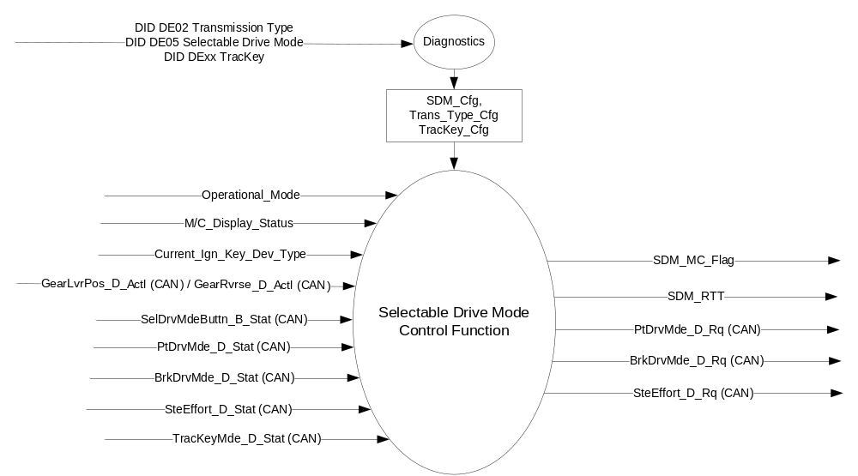

Inputs

- INTERNAL:
- Operational_Mode
- M/C_Display_Status
- Current_Ign_Key_Dev_Type (from MyKey Control Function STSS)
- Internally stored bit (SDM_Cfg) based on SDM parameter of DID DE05 indicating if the SDM feature is Enabled (0x1) or Disabled (0x0)
- Internally stored bit (Trans_Type_Cfg) based on Transmission Type parameter of DID DE02 indicating Automatic (0x0) or Manual (0x1) transmission

- MUX messages on the CAN bus:

- GearLvrPos_D_Actl Signal
Signal Name | Size  (bits) | Detail | Units | Res. | Offset | State  Encoded | Min | Max
GearLvrPos_D_Actl | 4 |  | SED | 1 | 0 |  | 0 (0x0) | 15 (0xF)
 |  | Park |  |  |  | 0x0
 |  | Reverse |  |  |  | 0x1
 |  | Neutral |  |  |  | 0x2
 |  | Drive |  |  |  | 0x3
 |  | Sport_DriveSport |  |  |  | 0x4
 |  | Low |  |  |  | 0x5
 |  | First |  |  |  | 0x6
 |  | Second |  |  |  | 0x7
 |  | Third |  |  |  | 0x8
 |  | Fourth |  |  |  | 0x9
 |  | Fifth |  |  |  | 0xA
 |  | Sixth |  |  |  | 0xB
 |  | Undefined_Treat_as_Fault |  |  |  | 0xC
 |  | Undefined_Treat_as__Fault |  |  |  | 0xD
 |  | Unknown_Position |  |  |  | 0xE
 |  | Fault |  |  |  | 0xF

- GearRvrse_D_Actl Signal
Signal Name | Size  (bits) | Detail | Units | Res. | Offset | State  Encoded | Min | Max
GearRvrse_D_Actl | 3 |  | SED | 1 | 0 |  | 0 (0x0) | 7 (0x7)
 |  | Inactive_not_confirmed |  |  |  | 0x0
 |  | Inactive_confirmed |  |  |  | 0x1
 |  | Active_not_confirmed |  |  |  | 0x2
 |  | Active_confirmed |  |  |  | 0x3
 |  | NotUsed_1 |  |  |  | 0x4
 |  | NotUsed_2 |  |  |  | 0x5
 |  | NotUsed_3 |  |  |  | 0x6
 |  | Fault |  |  |  | 0x7

- SelDrvMdeButtn_B_Stat Signal
Signal Name | Size  (bits) | Detail | Units | Res. | Offset | State  Encoded | Min | Max
SelDrvMdeButtn_B_Stat | 1 |  | SED | 1 | 0 |  | 0 (0x0) | 1 (0x1)
 |  | Not pressed |  |  |  | 0x0
 |  | Pressed |  |  |  | 0x1

- PtDrvMde_D_Stat Signal
Signal Name | Size  (bits) | Detail | Units | Res. | Offset | State  Encoded | Min | Max
PtDrvMde_D_Stat | 4 |  | SED | 1 | 0 |  | 0 (0x0) | 15 (0xF)
 |  | Normal |  |  |  | 0x0
 |  | Sport |  |  |  | 0x1
 |  | SnowWet |  |  |  | 0x2
 |  | TowHaulGradeAssist |  |  |  | 0x3
 |  | Not Used |  |  |  | 0x4
 |  | Not Used |  |  |  | 0x5
 |  | Not Used |  |  |  | 0x6
 |  | Not Used |  |  |  | 0x7
 |  | Not Used |  |  |  | 0x8
 |  | Not Used |  |  |  | 0x9
 |  | Not Used |  |  |  | 0xA
 |  | Not Used |  |  |  | 0xB
 |  | Not Used |  |  |  | 0xC
 |  | Not Used |  |  |  | 0xD
 |  | Not Used |  |  |  | 0xE
 |  | Faulty |  |  |  | 0xF

- BrkDrvMde_D_Stat Signal
Signal Name | Size  (bits) | Detail | Units | Res. | Offset | State  Encoded | Min | Max
BrkDrvMde_D_Stat | 3 |  | SED | 1 | 0 |  | 0 (0x0) | 7 (0x7)
 |  | Normal |  |  |  | 0x0
 |  | Sport |  |  |  | 0x1
 |  | Snow_Wet |  |  |  | 0x2
 |  | Track |  |  |  | 0x3
 |  | Drag |  |  |  | 0x4
 |  | Not Used |  |  |  | 0x5
 |  | Not Used |  |  |  | 0x6
 |  | Faulty |  |  |  | 0x7

- SteEffort_D_Stat Signal
Signal Name | Size  (bits) | Detail | Units | Res. | Offset | State  Encoded | Min | Max
SteEffort_D_Stat | 3 |  | SED | 1 | 0 |  | 0 (0x0) | 7 (0x7)
 |  | Normal |  |  |  | 0x0
 |  | Sport |  |  |  | 0x1
 |  | Comfort |  |  |  | 0x2
 |  | Not Used |  |  |  | 0x3
 |  | Not Used |  |  |  | 0x4
 |  | Not Used |  |  |  | 0x5
 |  | Not Used |  |  |  | 0x6
 |  | Not Used |  |  |  | 0x7

- TracKeyMde_D_Stat Signal
Signal Name | Size (bits) | Detail | Units | Res. | Offset | State Encoded | Min | Max
TracKeyMde_D_Stat | 2 |  | SED | 1 | 0 |  | 0 (0x0) | 3 (0x3)
 |  | ModeNotDetermined |  |  |  | 0x0
 |  | Active |  |  |  | 0x1
 |  | NotActive |  |  |  | 0x2
 |  | NotUsed |  |  |  | 0x3

Outputs
- MUX messages on the CAN bus:

- PtDrvMde_D_Rq Signal
Signal Name | Size  (bits) | Detail | Units | Res. | Offset | State  Encoded | Min | Max
PtDrvMde_D_Rq | 4 |  | SED | 1 | 0 |  | 0 (0x0) | 15 (0xF)
 |  | Normal |  |  |  | 0x0
 |  | Sport |  |  |  | 0x1
 |  | SnowWet |  |  |  | 0x2
 |  | TowHaulGradeAssist |  |  |  | 0x3
 |  | Not Used |  |  |  | 0x4
 |  | Not Used |  |  |  | 0x5
 |  | Not Used |  |  |  | 0x6
 |  | Not Used |  |  |  | 0x7
 |  | Not Used |  |  |  | 0x8
 |  | Not Used |  |  |  | 0x9
 |  | Not Used |  |  |  | 0xA
 |  | Not Used |  |  |  | 0xB
 |  | Not Used |  |  |  | 0xC
 |  | Not Used |  |  |  | 0xD
 |  | Not Used |  |  |  | 0xE
 |  | Faulty |  |  |  | 0xF

- BrkDrvMde_D_Rq Signal
Signal Name | Size  (bits) | Detail | Units | Res. | Offset | State  Encoded | Min | Max
BrkDrvMde_D_Rq | 3 |  | SED | 1 | 0 |  | 0 (0x0) | 7 (0x7)
 |  | Normal |  |  |  | 0x0
 |  | Sport |  |  |  | 0x1
 |  | Snow_Wet |  |  |  | 0x2
 |  | Track |  |  |  | 0x3
 |  | Drag |  |  |  | 0x4
 |  | Not Used |  |  |  | 0x5
 |  | Not Used |  |  |  | 0x6
 |  | Faulty |  |  |  | 0x7

- SteEffort_D_Rq Signal
Signal Name | Size  (bits) | Detail | Units | Res. | Offset | State  Encoded | Min | Max
SteEffort_D_Rq | 3 |  | SED | 1 | 0 |  | 0 (0x0) | 7 (0x7)
 |  | Normal |  |  |  | 0x0
 |  | Sport |  |  |  | 0x1
 |  | Comfort |  |  |  | 0x2
 |  | Not Used |  |  |  | 0x3
 |  | Not Used |  |  |  | 0x4
 |  | Not Used |  |  |  | 0x5
 |  | Not Used |  |  |  | 0x6
 |  | Not Used |  |  |  | 0x7

Function/Performance

Operational Modes

Mode | Differentiating Vehicle Conditions
Sleep Mode | Selectable Drive Mode Control Function Disabled
Limiting Mode | Selectable Drive Mode Control Function Disabled
Normal Mode | Selectable Drive Mode Control Function Enabled / Disabled
Crank Mode | Selectable Drive Mode Control Function Enabled / Disabled

Voltage Levels

Refer to the Cluster Features table located in the Operational Modes and Voltage Range Strategies Section in this SPSS.

Human-Machine Interface

Visual

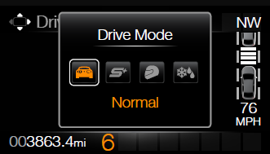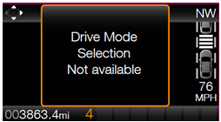

Graphics are for illustrative purposes only; refer to program specific graphics library.
.

Indicator Graphics / Display Format


For actual symbol pixel definition, see program specific HMI requirements.
Refer to symbols tbd.26, tbd.27, tbd.28, tbd.33, and tbd.34.

Indicator Color Coordinates

Refer to program specific HMI requirements for styling direction.

Indicator Characteristics

Pixel display in Message Center Display – SDM_RTT.

Audio

None

Switch Control Logic

The ECP module transmits an event periodic CAN signal (SelDrvMdeButtn_B_Stat) to inform the IPC if the SDM button is pressed or not pressed. The ECP handles all switch debouncing and fault conditions related to the SDM momentary toggle switch without relaying this information to the cluster. A button press is defined as a transition from Not pressed to Pressed. There is no press and hold for the SDM button – a press and hold shall constitute a single button press.

System Accuracy

Within a 100msec of receiving a message that results in a change of state the cluster will update the display to the proper status.

Operation: Performance and Functional

Subsystem Algorithm Flowcharts / State Diagrams

Figure 2: Selectable Drive Mode Control Function Diagnostic Flowchart

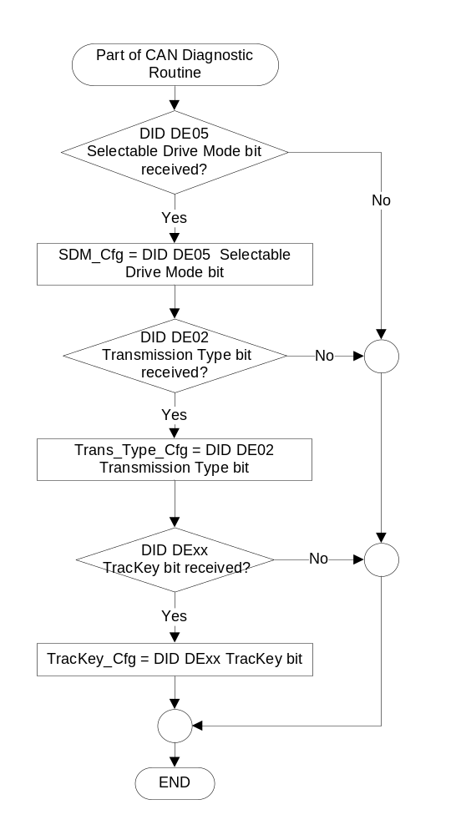
Figure 3: Selectable Drive Mode Control Function Flowchart
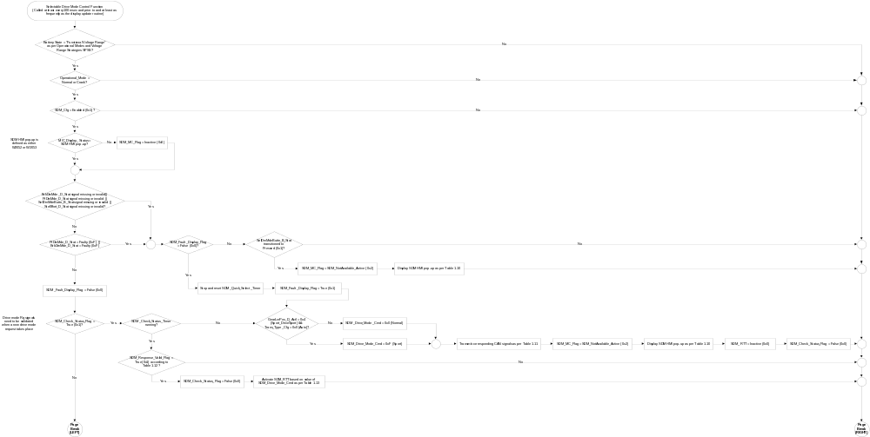

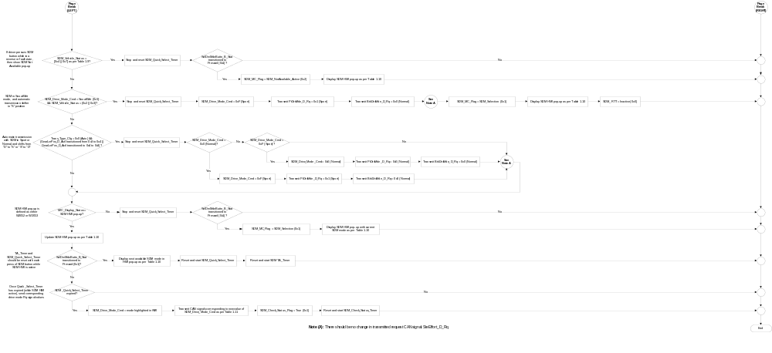
- SDM Mode Availability Based SDM_Cfg, Trans_Type_Cfg, Selected Gear, and MyKey Settings
SDM_Cfg | TracKey_Cfg | Trans_Type_Cfg | Selected Gear Position | Current_Ign_Key_Dev_Type | TracKeyMde_D_Stat Signal | SDM_Vehicle_Status | Valid States for SDM_Drive_Mode_Cmd
Enabled (0x1) | Enabled  (0x1) | Auto (0x0) | GearLvrPos_D_Actl  Park (0x0)  Neutral (0x2)  Drive (0x3) | <> Key_In_Ign_My_Key (0x2) | <> Active (0x1)  ||  Not Received | 0x0 | Normal (0x0)  Snow/Wet (0x1)  Sport+ (0x2)  Track (0x3)
 |  |  |  |  | Active (0x1) | 0x8 | Normal (0x0)  Sport+ (0x2)  Track (0x3)
Enabled (0x1) | X | Auto (0x0) | GearLvrPos_D_Actl  Park (0x0)  Neutral (0x2)  Drive (0x3) | Key_In_Ign_My_Key (0x2) | X | 0x1 | Normal (0x0)  Snow/Wet (0x1)  Sport+ (0x2)
Enabled (0x1) | X | Auto (0x0) | GearLvrPos_D_Actl  Sport_DriveSport (0x4) | <> Key_In_Ign_My_Key (0x2) | X | 0x2 | Sport+ (0x2)  Track (0x3)  Sport (0xF)
 |  |  |  | Key_In_Ign_My_Key (0x2) | X | 0x3 | Sport+ (0x2)  Sport (0xF)
Enabled (0x1) | X | Auto (0x0) | GearLvrPos_D_Actl  <> [0x0, 0x2, 0x3, 0x4]  (Reverse, Fault, Unused state) | X | X | 0x4 | SDM Not Available
Enabled (0x1) | Enabled  (0x1) | Manual (0x1) | GearRvrse_D_Actl  Inactive_not_confirmed (0x0)  Inactive_ confirmed (0x1)  (Forward or neutral gear) | <> Key_In_Ign_My_Key (0x2) | <> Active (0x1)  ||  Not Received | 0x5 | Normal (0x0)  Snow/Wet (0x1)  Sport+ (0x2)  Track (0x3)
 |  |  |  |  | Active (0x1) | 0x9 | Normal (0x0)  Sport+ (0x2)  Track (0x3)
Enabled (0x1) | X | Manual (0x1) |  | Key_In_Ign_My_Key (0x2) | X | 0x6 | Normal (0x0)  Snow/Wet (0x1)  Sport+ (0x2)
Enabled (0x1) | X | Manual (0x1) | GearRvrse_D_Actl  <> [0x0, 0x1]  (Reverse, Fault, Unused state) | X | X | 0x7 | SDM Not Available
All other cases |  |  |  |  |  | X | SDM Not Available

- Sample Graphics and MC WARNING MESSAGE ID # Based on SDM_MC_Flag
SDM_Cfg | SDM_MC_Flag | MC WARNING  MESSAGE ID # | SDM Pop-up Sample Graphics  *See Note Below
Enabled (0x1) | SDM_Selection  _Active (0x1) | W2053 | 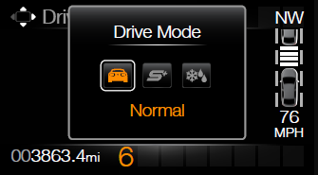  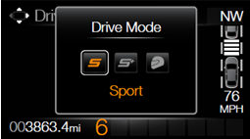  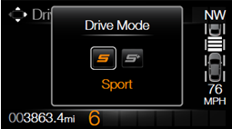
Enabled (0x1) | SDM_  NotAvailable_  Active (0x2) | W2052 | 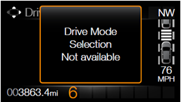
All other cases |  | X | No graphic shown

Note: W2053 should illustrate the available drives modes based on Table 1.9, where the highlighted

mode is the current value of SDM_Drive_Mode_Cmd.
- SDM_Drive_Mode_Cmd to Drive Mode Request Signals Mapping
SDM_Drive_Mode_Cmd | PtDrvMde_D_Rq | BrkDrvMde_D_Rq | SteEffort_D_Rq
Normal (0x0) | Normal (0x0) | Normal (0x0) | Normal (0x0)
Snow/Wet (0x1) | SnowWet (0x2) | Snow_Wet (0x2) | Normal (0x0)
Sport+ (0x2) | Sport (0x1) | Sport (0x1) | Sport (0x1)
Track (0x3) | Sport (0x1) | Track (0x3) | Sport (0x1)
Sport (0xF) | Sport (0x1) | Normal (0x0) | Normal (0x0)

- SDM_Response_Valid_Flag State Matrix
SDM_Drive_Mode_Cmd | PtDrvMde_D_Stat | BrkDrvMde_D_Stat | SteEffort_D_Stat | SDM_Response_Valid_Flag
Normal (0x0) | Normal (0x0) | Normal (0x0) | Normal (0x0) | True (0x1)
Snow/Wet (0x1) | SnowWet (0x2) | Snow_Wet (0x2) | Normal (0x0) | True (0x1)
Sport+ (0x2) | Sport (0x1) | Sport (0x1) | Sport (0x1) | True (0x1)
Track (0x3) | Sport (0x1) | Track (0x3) | Sport (0x1) | True (0x1)
Sport (0xF) | Sport (0x1) | Normal (0x0) | Normal (0x0) | True (0x1)
All other cases |  |  |  | False (0x0)

- SDM_RTT and Sample RTT Graphics Based on SDM_Drive_Mode_Cmd
SDM_Drive_Mode_Cmd | SDM_RTT | Sample RTT Graphics
Snow/Wet (0x1) | Snow/Wet (0x1)
Sport+ (0x2) | Sport+ (0x2)
Track (0x3) | Track (0x3)
All other cases | Inactive (0x0) | No graphic shown

Operation Description (supports algorithm flowcharts / state diagrams)

- There is no interaction between the 5-way steering wheel switches and the SDM feature. SDM is controlled directly via an external, momentary toggle switch, which is located in the ECP. The ECP is responsible for sending debounced pressed/not pressed information to the cluster via CAN.

- The first press of the dedicated SDM button shall bring up the SDM HMI pop-up. Subsequent presses of the SDM button shall advance the HMI to the next state/mode if the SDM HMI pop-up is active. SDM_Drive_Mode_Cmd and the corresponding CAN Rq signals shall not change until after the Quick_Select_Timer has elapsed according to the logic in Figure 3.

- Each press of the SDM button shall reset and restart the TA_timer for the SDM HMI pop-up if the SDM HMI is already active.

- If the SDM HMI is interrupted by any other pop-up or warning before the Quick_Select_Timer has elapsed, the SDM mode selection process should be aborted.

- Once the Quick_Select_Timer has elapsed, if another pop-up or warning gets activated, the SDM pop-up shall be deactivated as soon as the SDM mode display has been updated. (The SDM mode update can be concluded as complete once the “SDM_Check_Status_Flag” has a value of “False” (0x0) and corresponding RTT (if applicable) has been activated.).The SDM pop-up shall not wait for the minimum display timer to expire.

- W2053 is a TA* warning as per the global warning message list. Therefore, if SDM_MC_Flag <> SDM_Selection_Active (0x1), then W2053 should be dismissed.

- W2052 is a TA warning as per the global warning message list. Therefore, the value of SDM_MC_Flag does not have a direct impact on the dismissal of W2052.

- Certain drive modes are restricted under certain operating conditions. For example, “Track” mode is not available while a MyKey is in use. “Snow/Wet” mode is not available on automatic transmission vehicles while the shifter is in the “S” position. See Table 1.9 for more information.

- Upon key-on, SDM_Drive_Mode_Cmd shall default to Normal (0x0), PtDrvMde_D_Rq shall default to Normal (0x0), BrkDrvMde_D_Rq shall default to Normal (0x0), and SteEffort_D_Rq shall default to EPAS_Keyon_Effort as per “EPAS Selectable Steering Effort Function - S550 Specific - CGEA 1.3_v2.0+”.

- SDM is not related to, nor does it have any defined interactions with, the “Track Apps” or “TracKey” features.

- The IPC is responsible for requesting SDM modes, but it is the acting modules’ responsibility to make the appropriate decisions to determine if the request can be fulfilled and respond positively or negatively via its status signal (PtDrvMde_D_Stat, BrkDrvMde_D_Stat, or SteEffort_D_Stat).

Function Safety Classification (EMC)

Class B

Memory Storage
Parameter Name | Description | Value at  Battery Connect | Value at  Module Wake-up
Operational_Mode | 4 state indicator for cluster operational mode. | Limited | Limited, Normal or Crank
Current_Ign_Key_Dev_Type | Used to indicate the type of key currently in use in the vehicle. This parameter is identical in encoding to the IgnKeyType_D_Actl signal. | See STSS: “MyKey Control Function” | See STSS: “MyKey Control Function”
M/C_Display_Status | State indicator to identify which text is currently being displayed on Message Center display. See * | See * below | See * below
SelDrvMdeButtn_B_Stat | Input CAN signal that provides the debounced state of the SDM button (Pressed / Not pressed). | Not pressed (0x0) | Not pressed (0x0)
TracKeyMde_D_Stat Signal | Input from BCM providing status of TracKey | ModeNotDetermined  (0x0) | ModeNotDetermined  (0x0)
GearLvrPos_D_Actl | Input CAN signal for automatic transmission vehicles that indicates the gear shifter position. | Park (0x0) | Park (0x0)
GearRvrse_D_Actl | Input CAN signal for manual transmission vehicles that indicates whether the vehicle is in reverse or not. | Fault (0x7) | Fault (0x7)
PtDrvMde_D_Stat | Input CAN signal that provides the current powertrain mode status. | Normal (0x0) | Normal (0x0)
BrkDrvMde_D_Stat | Input CAN signal that provides the current ABS mode status. | Normal (0x0) | Normal (0x0)
SteEffort_D_Stat | Input CAN signal that provides the current EPAS steering feel status. | Normal (0x0) | Normal (0x0)
PtDrvMde_D_Rq | Output CAN signal to request a certain powertrain drive mode. | Normal (0x0) | Normal (0x0)
BrkDrvMde_D_Rq | Output CAN signal to request a certain ABS-ESC mode. | Normal (0x0) | Normal (0x0)
SteEffort_D_Rq | Output CAN signal to request a certain EPAS steering feel. | Normal (0x0) | See STSS: “EPAS Selectable Steering  Effort Function -  S550 Specific - CGEA 1.3 _v2.0+”
SDM_Check_Status_Flag | Internal parameter used to flag if the SDM handshaking (status checking) logic should take place. | False (0x0) | False (0x0)
SDM_Cfg | Internal flag used to indicate if SDM feature is present in the vehicle. | Use Stored Value | Use Stored Value
SDM_Drive_Mode_Cmd | Internal parameter that represents the current requested SDM mode. This parameter is identical in encoding to the Selectable_Drive_Mode_Stat DID. | Normal (0x0) | Normal (0x0)
SDM_Fault_Display_Flag | Internal parameter used to flag if SDM fault has occurred and has already been displayed. | False (0x0) | False (0x0)
SDM_MC_Flag | Internal flag used to control the state of the SDM selection pop-up. This variable can dismiss the SDM selection pop-up prior to the expiration of the TA_Timer. Encoding is as follows: Inactive (0x0), SDM_Selection_Active (0x1), and SDM_NotAvailable_Active (0x2). | Inactive (0x0) | Inactive (0x0)
SDM_RTT | SDM output displayed as an RTT. Encoding includes: Inactive (0x0), Snow/Wet (0x1), Sport+ (0x1), and Track (0x2). | Inactive (0x0) | Inactive (0x0)
SDM_Response_Valid_Flag | Internal parameter used to check if drive mode status signals (from PCM, ABS, and PSCM) are valid after a new drive mode request. | False (0x0) | False (0x0)
SDM_Vehicle_Status | Internal parameter that indicates the vehicle status based on Table 1.11. | 0x0 | 0x0
Trans_Type_Cfg | Internal flag used to indicate if transmission is automatic or manual. | Use Stored Value | Use Stored Value
TracKey_Cfg | State Indicator for feature presence controlled via CAN at EOL at VO plant. Defaulted to DISABLED at supplier manufacturing. | Use Stored Value | Use Stored Value
* Refer to Message Center X Display_Y Button Interface Section, where X and Y are appropriate values in this document.

Timer Name | Duration | Description | Min | Max | Resolution
SDM_Check_Status_Timer | 300ms | Used to limit the amount of time that EPAS, PCM, and ABS modules have to respond positively to a change in SDM mode. | 0ms | 2000ms | 50ms
SDM_Quick_Select_Timer | 700ms | Used to suppress the transmission of new SDM mode requests in between SDM button presses. | 0ms | 3000ms | 50ms
Note: Timers shall be programmable within the shown range, to at least the max value listed. Higher max values and finer resolutions are acceptable.

Reconfigurable Telltale

Yes. See Section 1.3.3.2 Indicator Graphics / Display Format, and Table 1.13.

Prove Out

Not applicable.

Message Center Msg

Yes. See Section 1.3.3.1 Visual, and Table 1.10.

Error Handling

Missing Message Strategy

The signals will be declared missing as per the Diagnostics section of this STSS.
DTCs states and history will be determined as per the Diagnostics section of this STSS.
If SDM_Cfg = Disabled, the cluster shall never log a missing message DTC due to this feature.

Diagnostics

Self Test

None.

Engineering Test Mode

Reference section “Dealer / Engineering Test Mode (ETM)”

Part II Performance

Supported Diagnostic DIDs (Service $22)
Number | DID / Common ID Name | PID Type | Comments / Information
$FDXX | Selectable_Drive_Mode_Stat | State Encoded | This DID will report the most recently requested drive mode.  0x0 = Normal  0x1 = Snow/Wet  0x2 = Sport+  0x3 = Track  0x4 - 0xE = Reserved  0xF = Sport
Note: Selectable_Drive_Mode_Stat is a supplier DID, which follows the same encoding as SDM_Drive_Mode_Cmd. This DID should be read-only.

DID $DEXX:
Block  Num | Block Description | Byte(s) | Bits | State: Description | "0" | "1" | Default
PACKETED BLOCKS
$02 | Option Content (B&A) | * | * | Transmission Type | Automatic | Manual | Automatic
$05 | Option Content (B&A) | * | * | Selectable Drive Mode | Disabled | Enabled | Disabled
 | *Byte and bit location to be identified in Part II Specification for this cluster

Supported Diagnostic Trouble Codes (DTCs)

DTCs shall be logged as per the diagnostics section of this SPSS.*

DTC | Description
C10000 | Lost Communication With ECM/PCM "A"
C12100 | Lost Communication With Anti-Lock Brake System (ABS) Control Module
C13100 | Lost Communication With Power Steering Control Module
C25600 | Lost Communication With Front Controls Interface Module "A"
C40100 | Invalid Data Received from ECM/PCM
C41500 | Invalid Data Received From Anti-Lock Brake System (ABS) Control Module
C42000 | Invalid Data Received From Power Steering Control Module
* If the missing signal has a related update bit, _UB, signal, then the “Invalid Data” DTC is to be logged. Otherwise, the “Lost Communication” DTC is logged.

Reference Specifications

IS-0001 WARNINGS/INDICATORS/DISPLAYS PROVEOUT
IS-0052 OPERATING VOLTAGES - FUNCTIONAL/PERFORMANCE
IS-0069 FUNCTIONAL IMPORTANCE CLASS
IS-0324 WINDSHIELD & OTHER REFLECTIONS
IS-0327 WARNING INDICATOR EVALUATION
IS-0379 NORTH AMERICAN WARNINGS AND INDICATORS STRATEGY

IL-0019 GENERAL ILLUMINATION DIMMING
IL-0021 CRAFTSMANSHIP - DISPLAYS
IL-0022 GENERAL ILLUMINTATION COLOR
IL-0023 CLARITY/LEGIBILITY/READABILITY
IL-0025 INTERIOR ILLUMINATION INTENSITY
IL-0027 VISUAL CONTRAST
IL-0043 OPERATIONAL ENVIRONMENT FUNCTIONALITY
IL-0045 COLOR
IL-0048 ILLUMINATION ACCEPTABILITY

03-0661 PLACEMENT: CONTROL AND DISPLAY LOCATIONS
03-0662 PLACEMENT: LOGICAL GROUPING FUNCTION AND USAGE
03-0664 PLACEMENT: DOWN VISION TO COMPONENTS WITH HIGH VISUAL DEMAND
03-0665 PLACEMENT: EXPECTED LOCATIONS OF CONTROLS AND DISPLAYS VDS
03-0670 INTERIOR VISIBILITY
03-0671 INTERIOR VISIBILITY: REFLECTIONS FROM COMPONENTS & SURFACES
03-0672 INTERIOR VISIBILITY: REFLECTIONS IN DISPLAYS
03-0673 INTERIOR VISIBILITY: VISUAL OBSCURATIONS
03-0674 INTERIOR VISIBILITY: ILLUMINATION CONTROLS / DISPLAYS
03-0675 INTERIOR VISIBILITY: VEILING GLARE
03-0677 INTERIOR VISIBILITY: SUNLIGHT WASHOUT
03-0681 IDENTIFICATION: CHARACTER AND SYMBOL SIZE
03-0682 IDENTIFICATION: LEGIBILITY
03-0685 IDENTIFICATION: SYMBOLS, ABBREV FOR CONTROL
03-0721 LOGIC OF OPERATION: OPERATIONAL STEREOTYPES
03-0722 LOGIC OF OPERATION: INTERPRETATION
03-0723 LOGIC OF OPERATION: USE OF SYSTEMS WITH VISUAL DISPLAYS

Revision History
STSS Module Revision History
Revision Level | Name | Change Description | Date
1.0 | M. Ehlert  V. Patel | Initial release of SDM feature cluster specification based on SDM ARL / system spec and direction from feature owners: Amin Kashi, Jeff Blazek, and Frank Desjarlais. | 11/7/2012
1.1 | M. Ehlert | Added logic to Figure 3 in order to check for PCM and ABS fault states, as well as missing status signals from PCM, ABS, and EPAS. This logic was inserted between the SDM_Cfg decision block and SDM_Check_Status_Flag decision block.  Changed wording throughout Figure 3. In most cases: “and” -> &&, “or” -> ||, “,” -> ||, and clarified that button presses are transitions to “pressed” … i.e., there’s no press and hold for SDM button. Inserted process block at end of flow chart to clarify setting the value of SDM_Drive_Mode_Cmd.  Added note to Figure 3 stating that TA warning timer should be reset any time a display/update HMI block is encountered.  The subset of modes in the “Valid states for SDM_Drive_Mode_Cmd” column of Table 1.11 have been sorted in ascending order as to disassociate it from the Sample Graphics column and the order of SDM modes.  The order of SDM modes has changed; graphics in Table 1.9 and Table 1.11 have been updated to reflect this change. Note that the program specific HMI requirements dictate the order of the modes and corresponding graphics.  Added SDM_Fault_Display_Flag to Section 1.3.5.4 to support additional logic in Figure 3. | 12/5/2012
1.2 | M. Ehlert | Updated Warning ID #s in Table 1.9 per request from HMI team. | 12/11/2012
2.0 | M. Ehlert | Cleanup and updates based on Q&A discussions with Denso.  Updated/clarified functional description. Updated DID DEXX values in Figure 1, Figure 2, and Section 1.5.3 based on IPC_Global_Config.  Split Figure 3 across two pages for better printing results and added clarification notes. In Figure 3: updated Table references, explicitly controlling state of SDM_MC_Flag now, split missing/invalid signals decision block and faulty decision block, added SelDrvMdeButtn_B_Stat signal to missing/invalid decision block, moved decision block checking if SDM_Vehicle_Status is equal to 0x4 or 0x7 before checking if SDM HMI pop-up is active, and clarified decision block checking transition between shifter “S” and “D” or vice versa.  Added an operational description for reference to Section 1.3.5.2 to support truth tables / flow charts. Moved tables from Section 1.3.5.2 to 1.3.5.1.  Updated Section 1.3.5.4 to include Cfg variables.  Updated Supported DTCs section to account for update bit related signals. | 3/12/2013
2.1 | V. Patel | Section 1.3.5.2: Added a requirement/logic that would safely allow another pop-up to get activated while the SDM pop-up is still actively displayed. Requirement captured in Red.  Section 1.3.5.1, tables 1.11, 1.12: Fixed typo. Value of SnowWet state was captured incorrectly in the PtDrvMde_D_Stat and PTDrvMde_D_Rq signals. The correct value is 0x2, not 0x3. | 7/22/2013
2.2 | V. Patel | Purpose of this update is to disable “Snow/Wet” mode when the vehicle is driven using a TracKey.  - Section 1.2.1, figure 1: Added “TracKey_Cfg” and TracKeyMde_D_Stat signal as inputs to the cluster.  - Section 1.2.2: Added table 1.6 for TracKeyMde_D_Stat CAN signal detail  - Section 1.3.5.1:  - Figure 2: Added config setting for TracKey_Cfg bit.  - Table 1.9: Added column for TracKey_Cfg and “TracKeyMde_D_Stat” CAN signals as inputs to the cluster. Outputs updated accordingly.  - Section 1.3.5.4: Added TracKey_Cfg and TracKeyMde_D_Stat as input memory parameters. | 6/5/2014
2.3 | V. Patel | Section 1.3.5.1, table 1.10: Fixed an error that would prevent driver from selecting Drive modes whenever TracKey feature was disabled via DExx. The cell of the first and fourth row of the second column needs to be a “X” (Don’t care). Also added “Not Received” or’ed with <>Active when checking for the “TracKeyMde_D_Stat” signal.  The BrkDrvMde_D_Stat and BrkDrvMde_D_Rq were updated to fix an issue found in the S550 SVT program. The same signals are used in this spec as well. However, the added state is not used here, hence this change does not affect the base program. The spec is updated just to synchronize the signals states. | 11/07/2014

